Lab Report

ECPE 170 – Computer Systems and Networks – Spring 2016

Name: Drew Overgaard

Lab Topic: Performance Measurement (Lab #: 5)

Question #1:
Create a table that shows the real, user, and system times measured for the bubble and quick sort algorithms.

Answer:

 | Bubble Sort | Quick Sort
Real | 0m36.578s | 0m8.498s
User | 0m36.448s | 0m0.116s
System | 0m0.028s | 0m0.284s

Question #2
In the sorting program, what actions take user time?
Answer:
The time spent running the code written by the programmer. The quick sort and bubble sort code that was written takes user time.

Question #3
In the sorting program, what actions take kernel time?
Answer:
This is the time that the Linux kernel spends servicing the application code for the bubble and quick sort functions.

Question #4
Which sorting algorithm is fastest?
Answer:
The Quick Sort algorithm is the fastest.

Question #5
Create a table that shows the total Instruction Read (IR) counts for the bubble and quick sort routines. (In the text output format, IR is the default unit used. In the GUI program, un-check the "% Relative" button to have it display absolute counts of instruction reads).
Answer:
 | 100000 | 50000 | 25000 | 12500
Bubble Sort | 164,783,130,352 | 41,222,602,063 | 10,304,655,114 | 2,588,643,511
Quick Sort | 45,458,267 | 22,672,463 | 22,672,463 | 4,916,642

Question #6
Create a table that shows the top 3 most active functions for the bubble and quick sort programs by IR count (excluding main()) - Sort by the "self" column if you're using kcachegrind, so that you see the IR counts for *just* that function, and not include the IR count for functions that it calls.
Answer:
Quick Sort Functions | Bubble Sort Functions
random_r | random_r
partition | strcmp'2
strcmp'2 | strcmp

Question #7
Create a table that shows, for the bubble and quick sort programs, the most CPU intensive line that is part of the most CPU intensive function. (i.e. First, take the most active function for a program. Second, find the annotated source code for that function. Third, look inside the whole function code - what is the most active line? If by some chance it happens to be another function, drill down one more level and repeat.)
Answer:
Quick Sort | Bubble Sort
int partition( int *array, int l, int r) { | if (array_start[j-1] > array_start[j])

Question #8:
Show the Valgrind output file for the merge sort with the intentional memory leak. Clearly highlight the line where Valgrind identified where the block was originally allocated.
Answer:
==3242== Memcheck, a memory error detector
==3242== Copyright (C) 2002-2013, and GNU GPL'd, by Julian Seward et al.
==3242== Using Valgrind-3.10.1 and LibVEX; rerun with -h for copyright info
==3242== Command: ./sorting_program merge
==3242== Parent PID: 2452
==3242==
==3242==
==3242== HEAP SUMMARY:
==3242== in use at exit: 400,000 bytes in 1 blocks
==3242== total heap usage: 1 allocs, 0 frees, 400,000 bytes allocated
==3242==
==3242== 400,000 bytes in 1 blocks are definitely lost in loss record 1 of 1
==3242== at 0x4C2CC70: calloc (in /usr/lib/valgrind/vgpreload_memcheck-amd64-linux.so)
==3242== by 0x400759: main (sorting.c:42)
==3242==
==3242== LEAK SUMMARY:
==3242== definitely lost: 400,000 bytes in 1 blocks
==3242== indirectly lost: 0 bytes in 0 blocks
==3242== possibly lost: 0 bytes in 0 blocks
==3242== still reachable: 0 bytes in 0 blocks
==3242== suppressed: 0 bytes in 0 blocks
==3242==
==3242== For counts of detected and suppressed errors, rerun with: -v
==3242== ERROR SUMMARY: 1 errors from 1 contexts (suppressed: 0 from 0)

Question #9:
How many bytes were leaked in the buggy program?
Answer:
400,000 when I ran using a size of 100,000. definitely lost: 400,000 bytes in 1 blocks

Question #10:
Show the Valgrind output file for the merge sort after you fixed the intentional leak.
Answer:
==3178== Memcheck, a memory error detector
==3178== Copyright (C) 2002-2013, and GNU GPL'd, by Julian Seward et al.
==3178== Using Valgrind-3.10.1 and LibVEX; rerun with -h for copyright info
==3178== Command: ./sorting_program merge
==3178== Parent PID: 2452
==3178==
==3178==
==3178== HEAP SUMMARY:
==3178== in use at exit: 0 bytes in 0 blocks
==3178== total heap usage: 1 allocs, 1 frees, 400,000 bytes allocated
==3178==
==3178== All heap blocks were freed -- no leaks are possible
==3178==
==3178== For counts of detected and suppressed errors, rerun with: -v
==3178== ERROR SUMMARY: 0 errors from 0 contexts (suppressed: 0 from 0)

Question #11:
Show the Valgrind output file for your quicksort.
Answer:
==3226== Memcheck, a memory error detector
==3226== Copyright (C) 2002-2013, and GNU GPL'd, by Julian Seward et al.
==3226== Using Valgrind-3.10.1 and LibVEX; rerun with -h for copyright info
==3226== Command: ./sorting_program quick
==3226== Parent PID: 2452
==3226==
==3226==
==3226== HEAP SUMMARY:
==3226== in use at exit: 0 bytes in 0 blocks
==3226== total heap usage: 0 allocs, 0 frees, 0 bytes allocated
==3226==
==3226== All heap blocks were freed -- no leaks are possible
==3226==
==3226== For counts of detected and suppressed errors, rerun with: -v
==3226== ERROR SUMMARY: 0 errors from 0 contexts (suppressed: 0 from 0)

Question #12:
How many seconds of real, user, and system time were required to complete the canny_detector with Lenna image (Lenna_org_1024.pgm)? Document the command used to measure this.
Answer:
time ./canny_detector IMAGES/Lenna_org_1024.pgm 11 1.1
real 0m2.023s
user 0m1.972s
sys 0m0.036s

Question #13:
Why does real time != (user time + system time)?
Answer:
time ./canny_detector IMAGES/Lenna_org_1024.pgm 11 1.1
real 0m2.023s
user 0m1.972s
sys 0m0.036s

Question #13:
In your report, put the intermediate and output images for the Lenna image. Specifically, put Edges.pgm, Gxy_img.pgm, and I_Angle.pgm.
Answer:



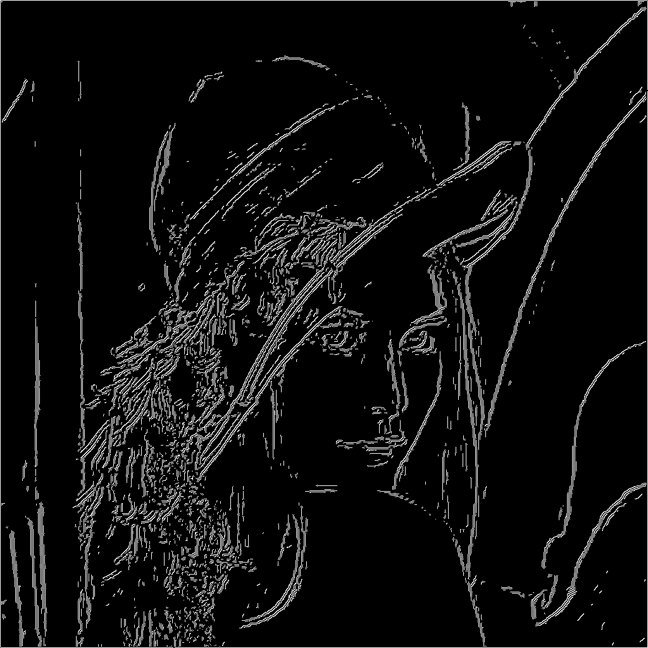


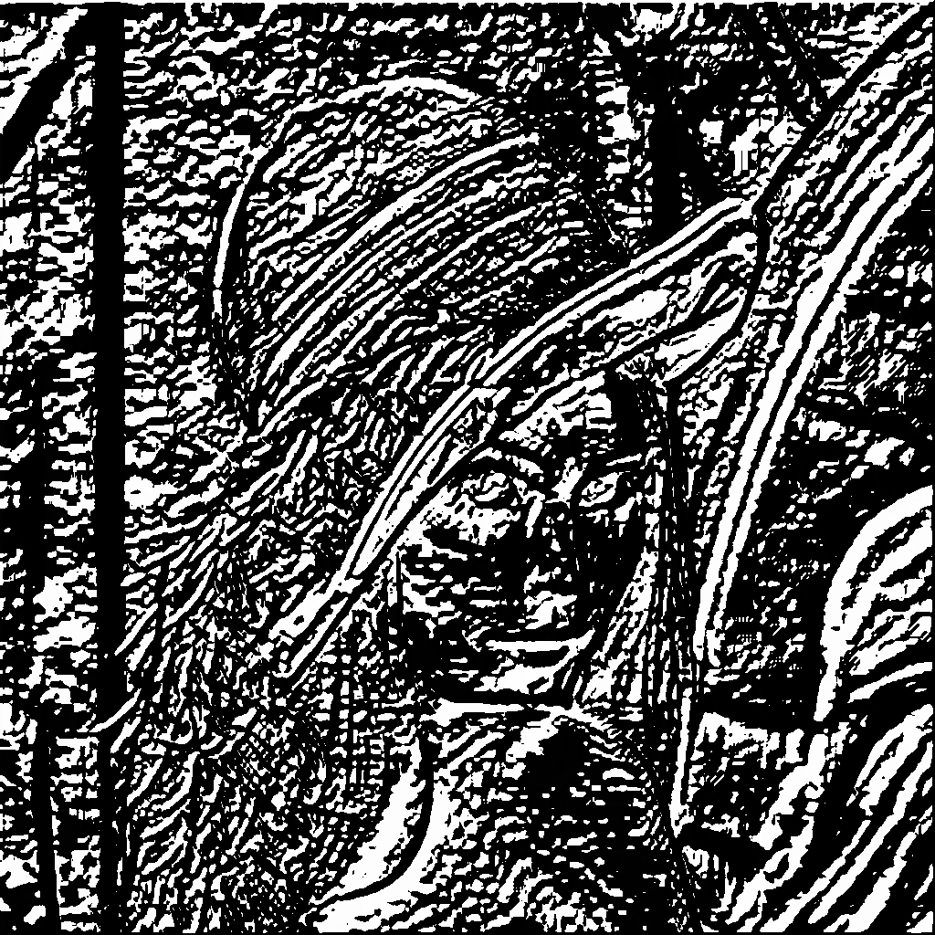

Question #15:
Excluding main() and everything before it, what are the top three functions run by canny_detector when you do count sub-functions in the total? Document the commands used to measure this. Tip: Sorting by the "Incl" (Inclusive) column in kcachegrind should be what you want.
Answer:
The top three functions are convolve, qsort, and qsortr. Also followed by angle.

Question #16:
Include a screen capture that shows the kcachegrind utility displaying the callgraph for the canny_detector, starting at main(), and going down for several levels.
Answer:

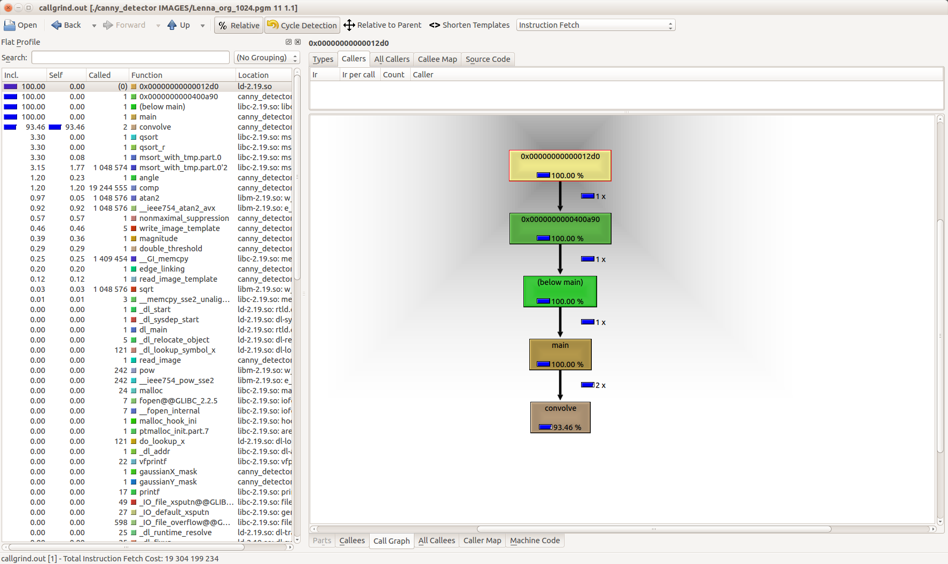

Question #17:
Which function dominates the execution time? What fraction of the total execution time does this function occupy?
Answer:
The function that dominates the execution time is the convolve function. It takes up 93.46% of the execution time.

Question #18:
Does this program show any signs of memory leaks?
Answer:
Yes, when I run valgrind --tool=memcheck --leak-check=yes --show-reachable=yes --num-callers=20 --log-file=memcheck.txt ./sorting_program merge, the output file produced says that there is a loss of 4,194,304 bytes.

==3521== 4,194,304 bytes in 1 blocks are definitely lost in loss record 1 of 1
==3521== at 0x4C2AB80: malloc (in /usr/lib/valgrind/vgpreload_memcheck-amd64-linux.so)
==3521== by 0x400BCD: read_image_template (image_template.h:35)
==3521== by 0x40210D: main (main.c:42)

